Photograph from Govisumber, No. 28

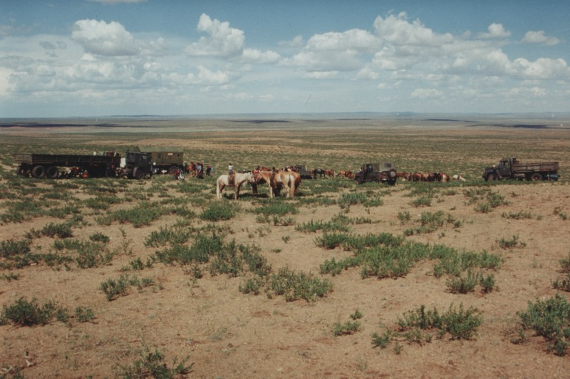

### identifier

a1fe7aae-14f2-4c3c-8429-449262cc36f2

### creator

Sneath, David

### type

Image

### coverage

Govisumber aimag

Mongolia

### description

### publisher

### source

scanned from a photographic print held in the archives of the Mongolia and Inner Asia Studies Unit, University of Cambridge

### rights

### subject

horses

### date

1995

### language

### format

image/png

### contributor

### original filename

sneath-govisumber_28.png

### relation

### extent

1776x1182 px

3.3MiB