Vitafit factory tour image - 2i4jqff4hv38r918g9mi0pclgg l

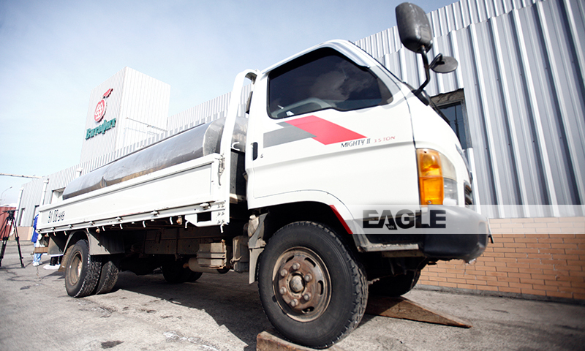

### identifier

a48725a5-3386-4fea-8c1f-d9058ee19716

### creator

### type

Image

### coverage

Mongolia

### description

Goyo yogurt factory tour image published by Eagle.mn.

### publisher

### source

### rights

### subject

Mongolia

dairy

nationalism

social media

### date

2014

### language

Vitafit factory tour image - Vitafit factory tour image - 2i4jqff4hv38r918g9mi0pclgg l

### format

image/jpeg

### original filename

2i4jqff4hv38r918g9mi0pclgg_l.jpg

### extent

370.6 KiB

800x480 px

### modified

2014-03-24 18:29:04