Young Herders' Congress and Livestock Exhibition in Sainshand

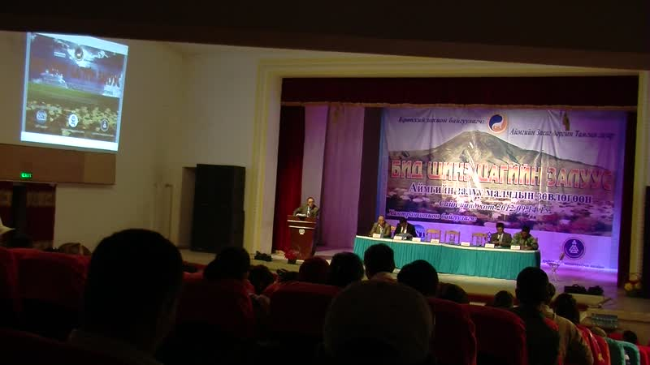

### identifier

a72394db-6fd3-4232-8624-1f3b22d8e6f1

### creator

Thrift, Eric

### type

Moving Image

### coverage

Mongolia

Dornogovi aimag

Sainshand sum

### description

This series of audiovisual recordings documents the proceedings of the Young Herders' Congress, held in Saran Khökhöö Theatre in Sainshand. The recordings at the end of the series present an overview of the livestock, dairy products, and other items presented at the livestock exhibition.

### publisher

### source

### rights

### subject

Pastoralism Videos

Herders Congress

Livestock Exhibition

### date

2012-09-14

### language

### remote embed url

https://archive.org/embed/a72394db-6fd3-4232-8624-1f3b22d8e6f1

### modified

2018-01-18 09:49:51

### table of contents

|  |  |  |
| --- | --- | --- |
| time | clip | description |
| 0:00:00 | 300G0167 01 | Overview of the livestock exhibition grounds, prior to the opening. |
| 0:00:56 | 300G0168 01 |  |
| 0:14:49 | 300G0168 02 |  |
| 0:28:43 | 300G0168 03 |  |
| 0:42:37 | 300G0168 04 |  |
| 0:56:31 | 300G0168 05 |  |
| 1:10:25 | 300G0168 06 |  |
| 1:24:19 | 300G0168 07 |  |
| 1:38:12 | 300G0168 08 |  |
| 1:43:11 | 300G0168 09 |  |
| 1:57:05 | 300G0168 10 |  |
| 2:04:31 | 300G0169 01 |  |
| 2:18:25 | 300G0169 02 |  |
| 2:32:19 | 300G0169 03 |  |
| 2:46:13 | 300G0169 04 |  |
| 3:00:06 | 300G0170 01 |  |
| 3:00:47 | 300G0171 01 |  |
| 3:05:01 | 300G0172 01 |  |
| 3:06:04 | 300G0173 01 |  |
| 3:08:04 | 300G0174 01 |  |
| 3:08:28 | 300G0175 01 |  |
| 3:10:13 | 300G0176 01 |  |