Photographs from Barguzin, No. 01

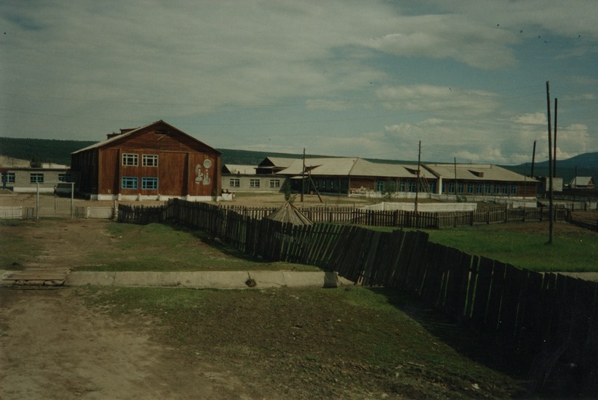

### identifier

a73fd0f2-5952-448b-897c-615ea6e26481

### creator

Gomboev, Bair

### type

Image

### coverage

Barguzin

Burtyatia

Russian Federation

### description

Argada village -- local middle school

### date

1993-07

### language

### format

image/png

### modified

2017-05-25 01:56:06

### original filename

bair-batbuyan-photos-01.png

### source

Scanned from a photographic print held in the archives of the Mongolia and Inner Asia Studies Unit, University of Cambridge

### extent

3.3 MiB

1777x1191 px

### subject

schools