Feltmaking at Khandgait, Yeroo sum, Selenge aimag (part I)

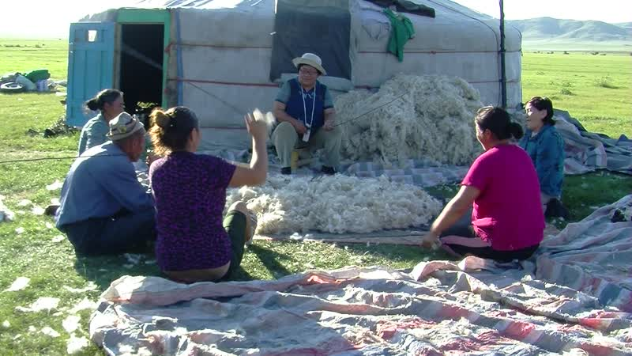

### identifier

a74d367f-fc51-4908-894c-83371c2060cc

### creator

Thrift, Eric

### type

Moving Image

### coverage

Mongolia

Selenge aimag

Yeröö sum

### description

This series of videos documents feltmaking at Purevjav's place in Khandgait, Yeroo, over two days in late summer. Several families participated in the feltmaking, each bringing their own wool and sharing in the labour of beating and drawing the felt. I visited Purevjav in the company of my mother, along with Dolgorsuren and Gerlee from Tasag. The recordings in this first part of the series depict the beating of wool, as well as milking cows in the evening on the first day of the feltmaking.

### publisher

### source

### rights

### subject

Pastoralism Videos

Felt Making

Beating Wool

Milking Cattle

Purevjav

### date

2012-08-12

### language

### remote embed url

https://archive.org/embed/a74d367f-fc51-4908-894c-83371c2060cc

### format

inode/directory

### modified

2018-03-02 09:37:44

### original filename

PastoralismVideos--2012-08-12--FeltMaking--BeatingWool--MilkingCattle--Purevjav--Selenge-Yeroo.vclips

### table of contents

|  |  |  |
| --- | --- | --- |
| time | clip | description |
| 0:00:00 | 300G0089 01 | Purevjav's in-laws have laid out wool on a thick rubber mat and are beating it, along with Purevjav's son Ochir, using metal rods. Beating the wool in this way serves to disentangle the fibres, similar to carding. |
| 0:07:55 | 300G0090 01 | Beating wool. |
| 0:21:49 | 300G0090 02 | Beating wool. |
| 0:35:42 | 300G0090 03 | Beating wool. |
| 0:49:36 | 300G0090 04 | Beating wool. |
| 1:03:30 | 300G0090 05 | Beating wool. |
| 1:04:01 | 300G0091 01 | Beating wool. |
| 1:05:54 | 300G0092 01 | Beating wool. |
| 1:19:47 | 300G0093 01 | Beating wool. |
| 1:33:41 | 300G0093 02 | Beating wool. |
| 1:47:34 | 300G0093 03 | Beating wool. |
| 1:49:30 | 300G0093 04 | Beating wool. |
| 2:03:23 | 300G0093 05 | Beating wool. |
| 2:17:17 | 300G0093 06 | Beating wool. |
| 2:31:10 | 300G0093 07 | Beating wool. |
| 2:45:04 | 300G0093 08 | Beating wool. |
| 2:48:04 | 300G0094 01 | Beating wool. Aaruul set out to dry on a cloth laid out on the ground, next to Purevjav's yurt. Purevjav and his youngest daughter go to milk the cows. |
| 3:01:57 | 300G0094 02 | Purevjav and his daughter milk the cows. |
| 3:15:51 | 300G0094 03 | Purevjav and his daughter finish milking the cows. They return to the yurt. |