Photograph from Inner Mongolia, No. 18

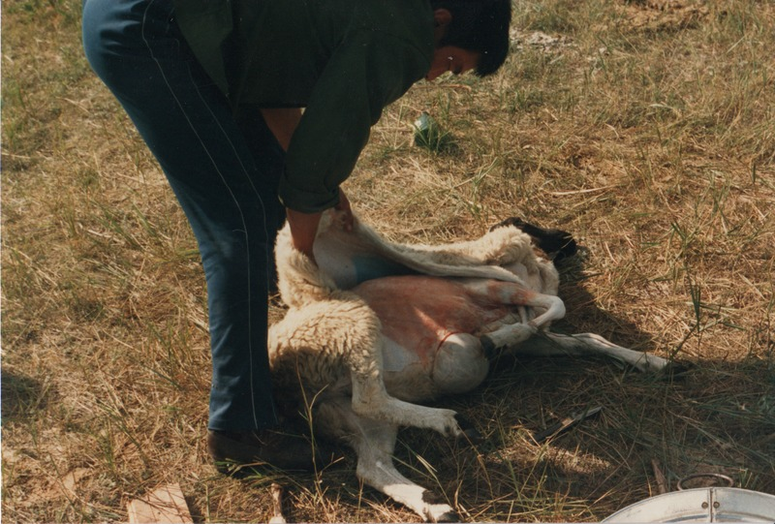

### identifier

adf37a08-1abd-47bc-9b68-295cff01b7b5

### creator

Sneath, David

### type

Image

### coverage

Inner Mongolia

PRC

### description

Slaughtering a sheep.

### publisher

### source

Scanned from a photographic print held in the archives of the Mongolia and Inner Asia Studies Unit, University of Cambridge.

### rights

### subject

sheep slaughter

### date

ca. 1988

### language

### original filename

sneath-inner-mongolia-1980s.png_18.png

### relation

### extent

3.5 MiB

1747x1182 px

### contributor

### format

image/png

### modified

2017-05-25 11:09:56