Through Asia, Vol. 2

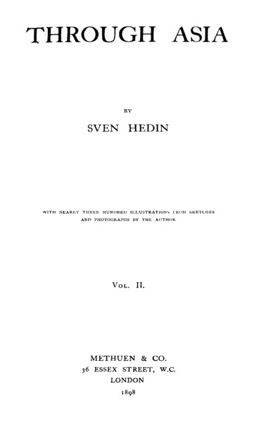

### identifier

afd90661-7527-4b1f-91e3-e0c17f2ed116

### creator

Hedin, Sven

### type

Text

### coverage

Inner Asia

### description

[From the preface] This work does not claim to be anything more than a plain account of my journeys through Asia during the years 1893 to 1897. It has been written for the general public, and presents nothing more than a description of my travels and the more memorable of my experiences -- not by any means the whole of my experiences. ... [T]he great bulk of the scientific observations I made find no place in the present volumes. All the same I believe the geographer will be able to discover in them something or other that will be of interest to him.

### publisher

Methuen & Co.

### source

<https://archive.org/details/in.ernet.dli.2015.80019>

### rights

Public domain

### subject

expeditions

### date

1898

### language

English

### format

application/pdf

### modified

2017-10-09 14:44:55

### original filename

2015.80019.Through-Asia-Vol-Ii.pdf

### extent

201.0 MiB

### remote embed url

https://archive.org/embed/in.ernet.dli.2015.80019