Oral history interview No. 090213A with Nadmid (b. 1936): transcript

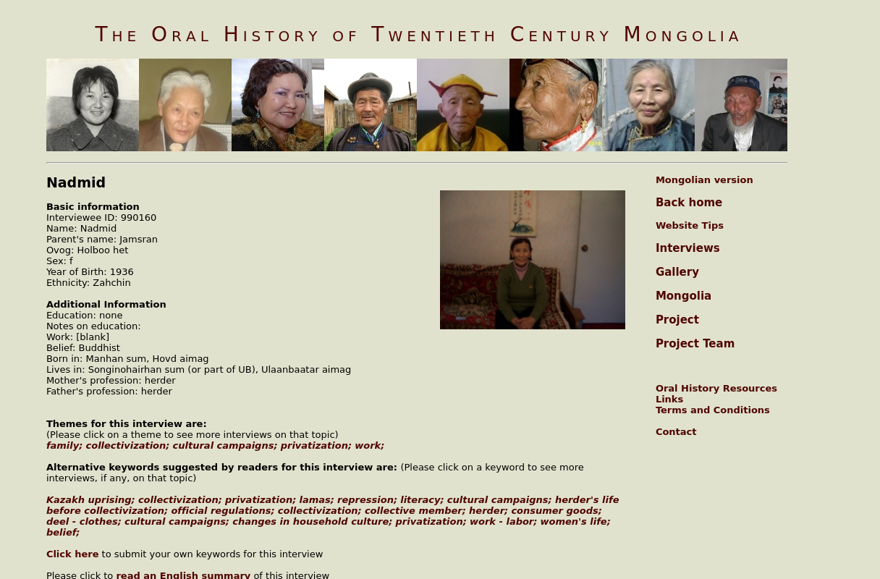

### identifier

b0b61bb7-b992-497d-819f-51b5ba17003e

### creator

Nadmid

### type

Text

### coverage

### description

### publisher

### source

### rights

### subject

### date

2009

### language

### format

text/plain

### contributor

Sarantsetseg

### original filename

090213A-Nadmid-transcript.url

### relation

### extent

79.0 B