Map of movements among participant households in Uvs

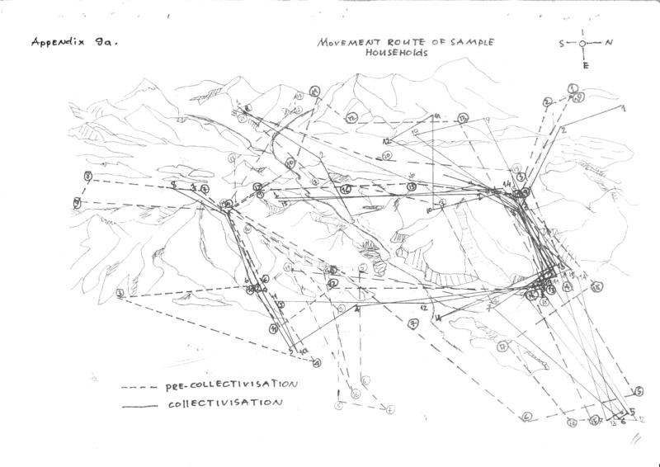

### identifier

b16a8fd5-d110-4b60-9831-10601d63cf5d

### creator

Erdenebaatar, B

### type

Image

### coverage

Mongolia

Uvs aimag

Turgen sum

Sagil sum

### description

Taken from Erdenebaatar's report on mobility patterns (Appendix 9a). This map contrasts collective-era and post-collective mobility patterns among households who participated in ethnographic research.

### publisher

### source

Scanned from an original document held in the archives of the Mongolia and Inner Asia Studies Unit, University of Cambridge.

### rights

### subject

mobility patterns

maps

### date

ca. 1992

### language

### original filename

macarthur-erdenebaatar-household-moves-map_1.png

### relation

### extent

208.9 KiB

3507x2480 px

### contributor

### format

image/png

### modified

2017-05-25 10:39:50