Caroline Humphrey - Buryatia photos - No. 2-28

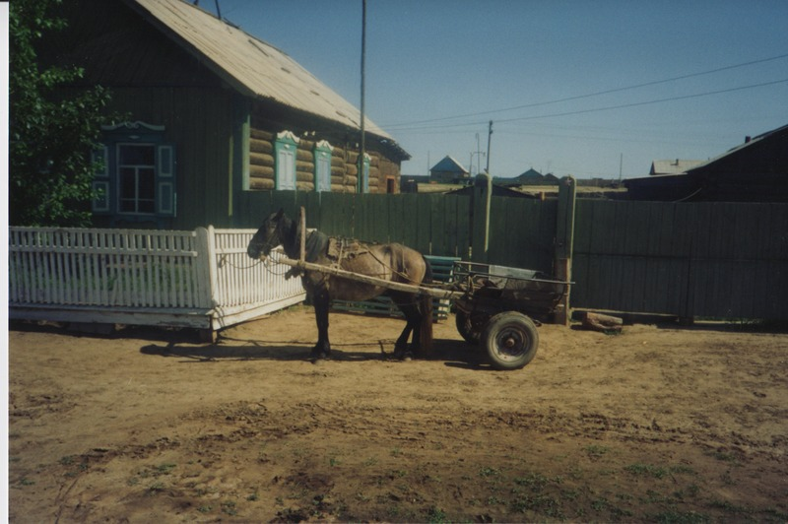

### identifier

b1f0c2d7-6f36-42c6-90e3-1c83da0a3edc

### creator

Humphrey, Caroline

### type

Image

### coverage

Bayangol

Khilgana

Karl Marx Collective

Buryatia

USSR

### description

Horse-drawn cart, town centre.

### publisher

### source

Scanned from a print held in the archives of the Mongolia and Inner Asia Studies Unit, University of Cambridge.

### rights

### subject

### date

1993

### language

### contributor

### original filename

Humphrey-Buryatia-photos-2-28.png

### relation

### extent

3.3MiB

1799x1196 px

### format

image/png