Дуулиан Шуугиан - өнөөх сайхан гоё тараг гоё ундаа урбанек...

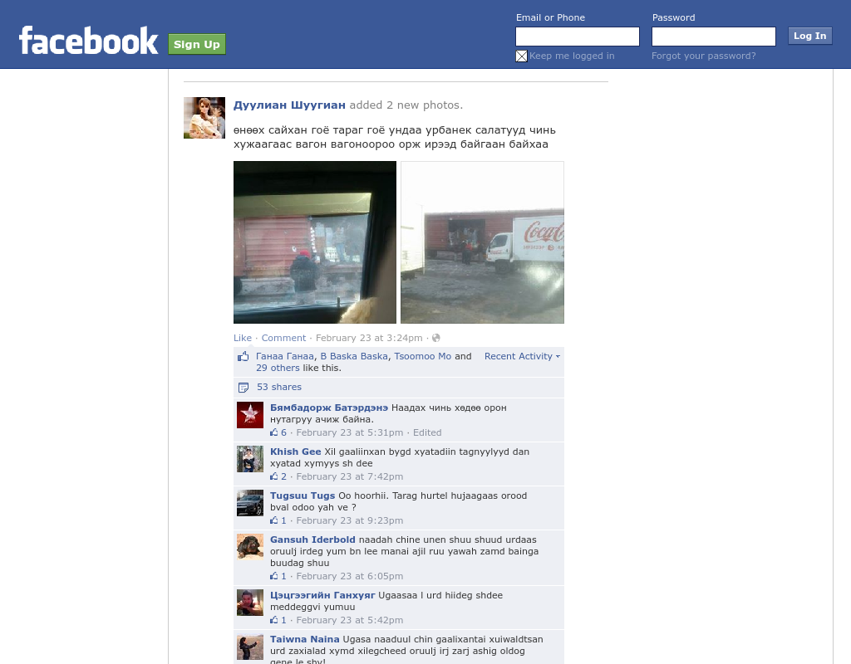

### identifier

b3486819-ee4c-4d75-828c-68f5eea3e7f2

### creator

### type

Text

### coverage

Mongolia

### description

### publisher

### source

https://www.facebook.com/duulian.shuugian/posts/275014779325338

### rights

### subject

Mongolia

dairy

nationalism

social media

### date

18 Mar 2014 15:11:17

### language

Mongolian

### format

text/plain

### modified

2018-01-11 14:12:43

### original filename

facebook.com.Duulian_shuugian.url

### extent

63.0 B