Photograph of Handgate, Xinjiang by Tsui Yen Hu, 1993, No. 41

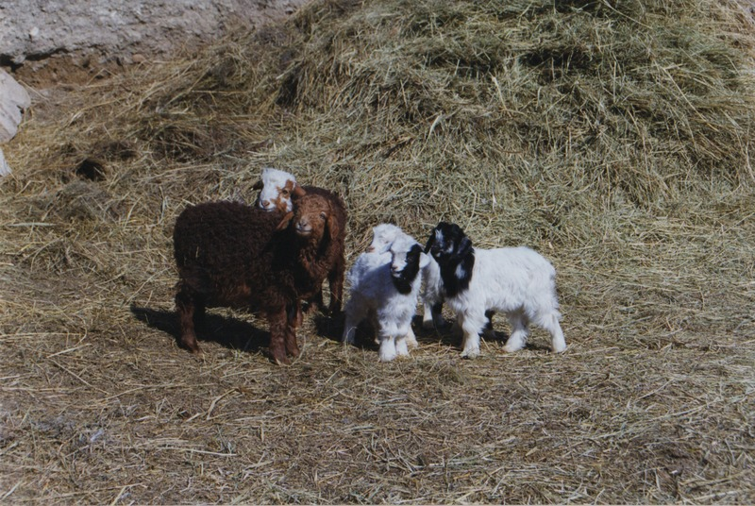

### identifier

b3db99f7-baca-4155-ade5-219323f0c0ac

### creator

Tsui Yen Hu

### type

Image

### coverage

Altai district

Handgate

PRC

Xinjiang

### description

New born lambs and hay, at the spring pasture

### publisher

### source

Scanned from colour print held in the archives of the University of Cambridge MacArthur Project "Environmental and Cultural Conservation in Inner Asia", Mongolia and Inner Asia Studies Unit.

### rights

### subject

pastoralism

### date

1993-05-04

### language

### format

image/png

### contributor

### original filename

TsuiYenHu-Handgate-1993-41.png

### relation

### extent

1777x1191 px

4.0 MiB