Losing Ground

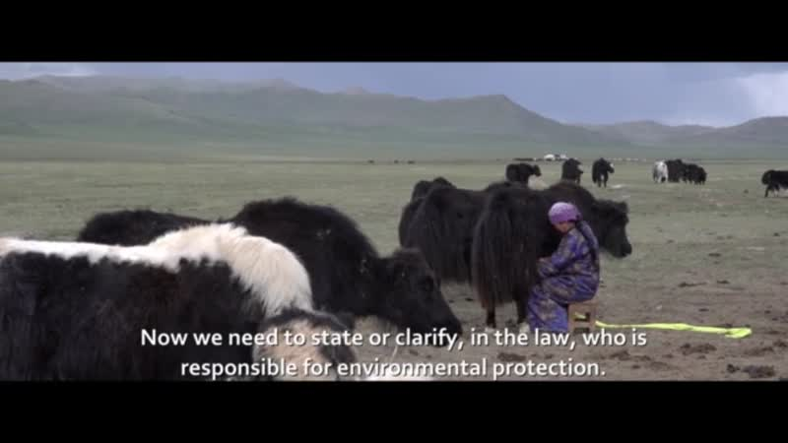

### identifier

b4f3dafe-2fd8-4d5a-9672-683c84f682eb

### creator

Rappa, Bradley

### type

Moving Image

### coverage

Mongolia

### description

[Directors Statement] In June 2013 and 2014 I traveled to a number of remote locations in Mongolia to observe and document the daily activities of the rural, pastoral families who have been raising livestock and living off the land for generations. My goal is to illustrate how, in a few short decades, the traditional Mongolian lifestyle has undergone rapid and profound changes. In addition to converting to a democratic, multi-party system and a liberal market economy, Mongolia is also currently entering a mining boom that is generating additional economic growth for some urban Mongolians. Yet, at the same time, many rural Mongolians find themselves struggling to survive. Harsh winters, dwindling herds, and habitat loss due to destructive mining practices and over grazing are forcing many families to abandon the countryside with the hopes of finding work elsewhere. In short, climate change, and the detrimental impacts of industrialization and global consumer culture are adversely affecting the traditionally sustainable lifestyles of these rural Mongolians. This film and the contacts I have made along the way, are leading me to further projects in Mongolia that will help to inform academics, policy makers and Mongolian citizens of the importance of curbing destructive mining practices while emphasizing the importance of providing education, regulation and environmentally sound energy practices.

### publisher

### source

<https://vimeo.com/channels/1234071/85559624>

### rights

Copyright Bradley Rappa. All rights reserved.

### subject

Mongolia

environment

mining

pastoralism

urbanization

### date

2014

### language

English subtitles

Mongolian

### format

video/mp4

### contributor

### original filename

losing-ground.mp4

### relation

### extent

144.4MiB

1828.586667

### public

FALSE