Caroline Humphrey Mongolia Super8 film no. 10

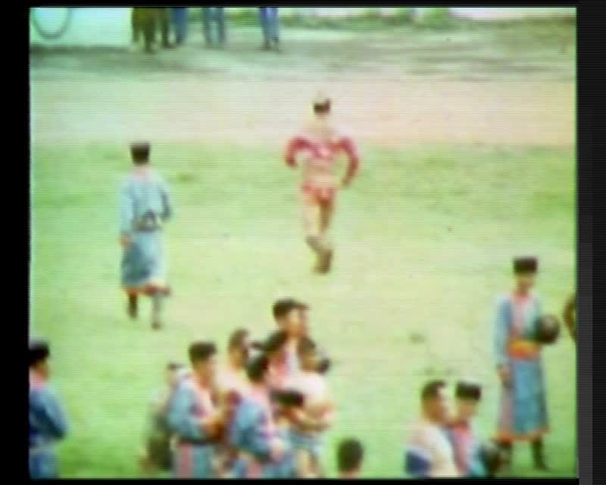

### identifier

b906d1db-7b9a-4d29-ae26-61d1e78680f2

### creator

Humphrey, Caroline

### type

Moving Image

### coverage

Mongolia

Ulaanbaatar

### description

Naadam Festival in Ulaanbaatar. Procession, dancing, beginning of the wrestling competition, military band.

### publisher

MIASU

### source

Digitized from a VCR transfer tape held at the Mongolia and Inner Asia Studies Unit, University of Cambridge

### rights

Copyright Caroline Humphrey

### subject

Naadam

wrestling

### date

ca. 1970s

### language

None

### original filename

humphrey-super8-mongolia-10.mp4

### extent

912.5 MiB

217.600000

### format

video/mp4

### modified

2017-06-16 09:06:41

### alternate url

https://archive.org/embed/b906d1db-7b9a-4d29-ae26-61d1e78680f2