Caroline Humphrey - Buryatia photos - No. 23

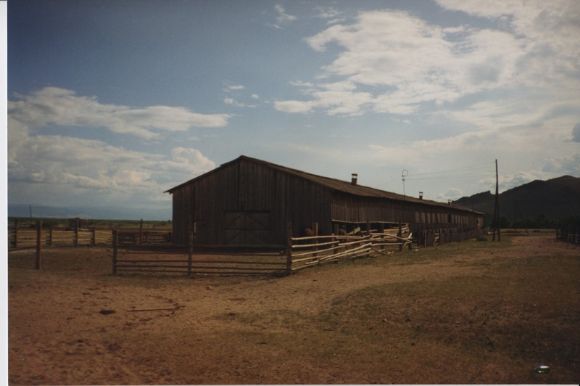

### identifier

bbff7957-1b2c-4381-8c0b-c253e1fc6f99

### creator

Humphrey, Caroline

### type

Image

### coverage

Ulung Collective

Buryatia

USSR

### description

### publisher

### source

Scanned from a print held in the archives of the Mongolia and Inner Asia Studies Unit, University of Cambridge.

### rights

### subject

### date

1993-07-25

### language

### extent

3.1MiB

1799x1196 px

### contributor

### original filename

Humphrey-Buryatia-photos-23.png

### relation

### format

image/png