How should Inner Mongolia be developed?Inner Mongolia: the dialectics of colonization and ethnicity building

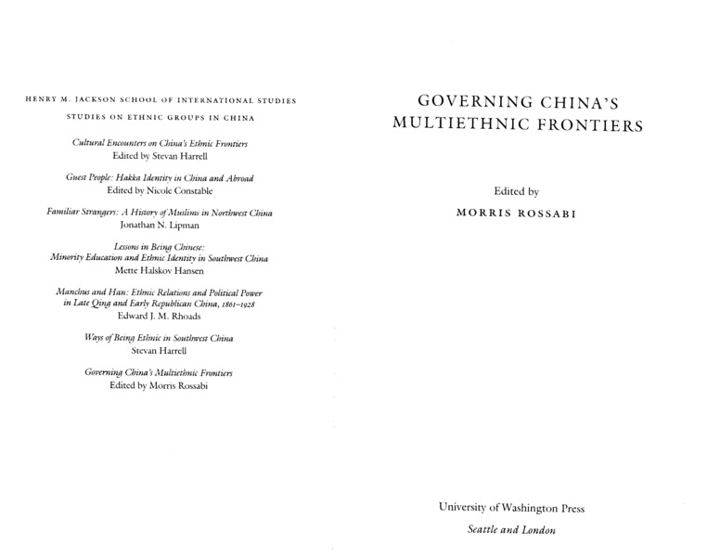

### identifier

bda29f65-f332-460a-ba4d-9aebcc9cb482

### creator

Uradyn E Bulag

### type

Text

### coverage

Inner Mongolia

PRC

### description

The Chinese regime, which has granted unified autonomy to the Mongols, has also instituted various mechanisms to undermine the Mongols as a viable community. The Mongol ethnicity generated by these mechanisms is so perplexing tht the Mongols aspire not only to maintain an ethnic political entity but also to live as normal citizens of the Chinese state. Furthermore, they simultaneously emphasize group cohesion and individualism. Contrary to the current dominant view that the Chinese regime is a builder of minzu, in fact, it builds in order to destroy.

### publisher

### source

Bulag, Uradyn E. "Inner Mongolia: the dialectics of colonization and ethnicity building." Governing China’s multiethnic frontiers (2004): 84-116.

### rights

### subject

Inner Asia

### date

2004

### language

English

### format

application/pdf

### modified

2017-12-24 15:19:15

### original filename

Bulag2004.pdf

### extent

1.6 MiB