Photograph of Handgate, Xinjiang by Tsui Yen Hu, 1993, No. 40

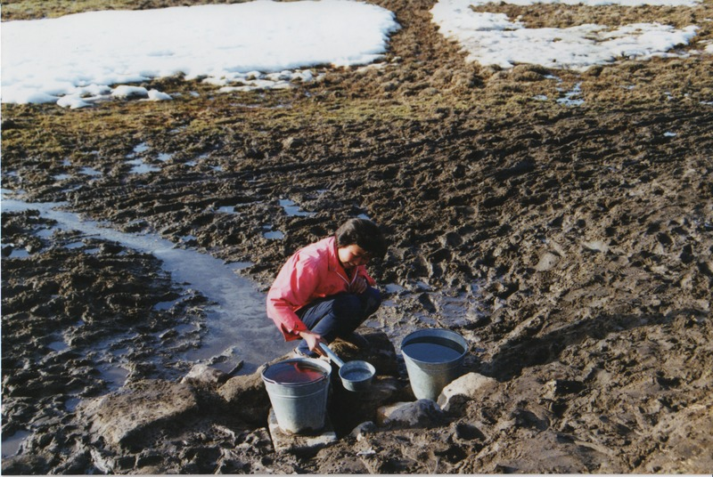

### identifier

bdaa8983-4a79-4c49-aafe-501dd6bf4598

### creator

Tsui Yen Hu

### type

Image

### coverage

Altai district

Handgate

PRC

Xinjiang

### description

A freshwater spring at the spring pastures, with herders using the water.

### publisher

### source

Scanned from colour print held in the archives of the University of Cambridge MacArthur Project "Environmental and Cultural Conservation in Inner Asia", Mongolia and Inner Asia Studies Unit.

### rights

### subject

pastoralism

### date

1993-03-26

### language

### format

image/png

### contributor

### original filename

TsuiYenHu-Handgate-1993-40.png

### relation

### extent

1777x1191 px

3.8 MiB