Timeline Photos - Юу хийгээд байгаам бэ? | Facebook

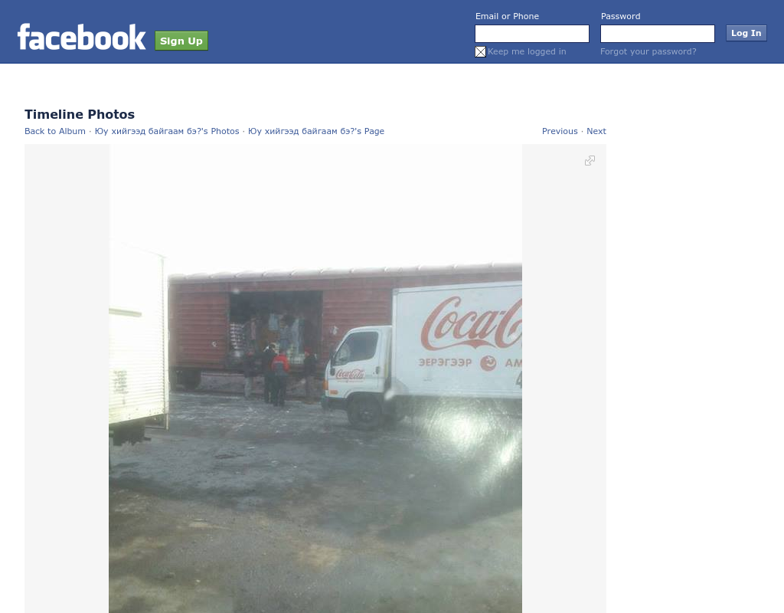

### identifier

c0034916-7b3a-4fdd-b016-3457520a7dc1

### creator

### type

Text

### coverage

Mongolia

### description

### publisher

### source

https://www.facebook.com/photo.php?fbid=233793430077896&amp;set=a.195242403932999.1073741827.191588557631717&amp;type=1&amp;permPage=1

### rights

### subject

Mongolia

dairy

nationalism

social media

### date

18 Mar 2014 11:48:51

### language

Mongolian

### format

text/plain

### modified

2018-01-11 14:12:43

### original filename

facebook.com.Yuu_khiigeed_baigaam.url

### extent

134.0 B