Caroline Humphrey Mongolia Super8 film no. 12

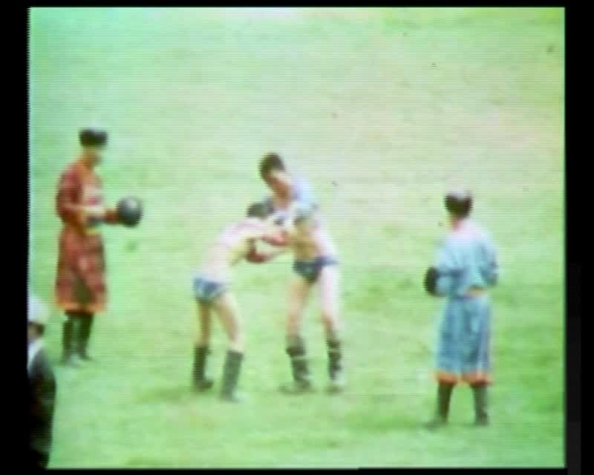

### identifier

c19b13a6-1dba-4170-9497-4d5bb55d5468

### creator

Humphrey, Caroline

### type

Moving Image

### coverage

Mongolia

Ulaanbaatar

### description

Wrestling competition, Naadam Festival (Ulaanbaatar)

### publisher

MIASU

### source

Digitized from a VCR transfer tape held at the Mongolia and Inner Asia Studies Unit, University of Cambridge

### rights

Copyright Caroline Humphrey

### subject

Naadam

wrestling

### date

ca. 1970s

### language

None

### original filename

humphrey-super8-mongolia-12.mp4

### extent

782.5 MiB

217.003000

### format

video/mp4

### modified

2017-06-16 09:17:44

### alternate url

https://archive.org/embed/c19b13a6-1dba-4170-9497-4d5bb55d5468