Caroline Humphrey - Buryatia photos - No. 3-11

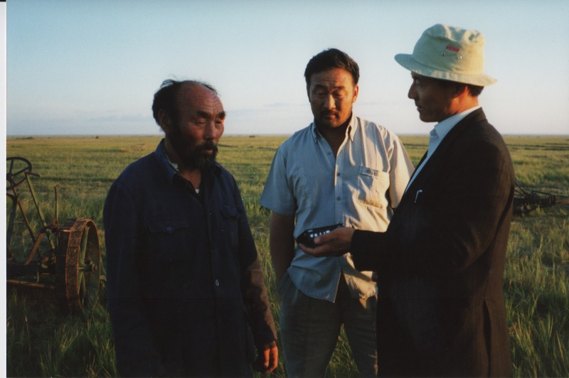

### identifier

c394cc15-4912-4c5e-ab8e-c74f7d4452e0

### creator

Humphrey, Caroline

### type

Image

### coverage

Khargant

### description

Khurelbaatar interviewing an elderly man.

### publisher

### source

Scanned from a print held in the archives of the Mongolia and Inner Asia Studies Unit, University of Cambridge.

### rights

### subject

### date

1993

### language

### contributor

### original filename

Humphrey-Buryatia-photos-3-11.png

### relation

### extent

3.1MiB

1799x1196 px

### format

image/png