Photograph of Handgate, Xinjiang by Tsui Yen Hu, 1993, No. 18

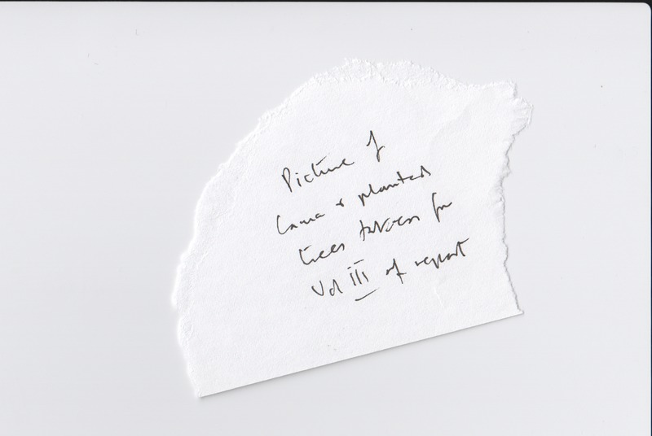

### identifier

c4989792-b1af-4ea8-afa8-37282d519fd6

### creator

Tsui Yen Hu

### type

Image

### coverage

Altai district

Handgate

PRC

Xinjiang

### description

The lama, and the trees he planted

### publisher

### source

Scanned from colour print held in the archives of the University of Cambridge MacArthur Project "Environmental and Cultural Conservation in Inner Asia", Mongolia and Inner Asia Studies Unit.

### rights

### subject

Buddhism

### date

1993-05-08

### language

### format

image/png

### contributor

### original filename

TsuiYenHu-Handgate-1993-18.png

### relation

### extent

1777x1191 px

2.9 MiB