Caroline Humphrey Mongolia Super8 film no. 20

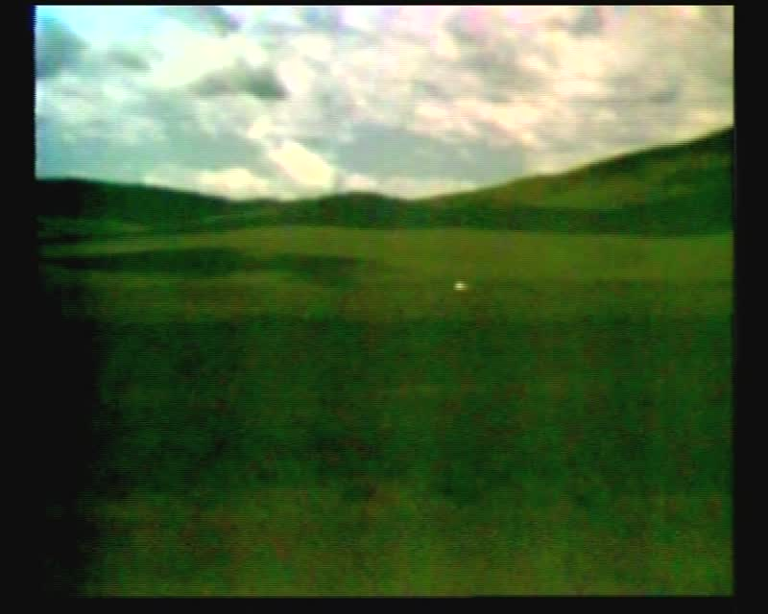

### identifier

c4dd23ba-6a86-483a-9958-dc0a05ffbf27

### creator

Humphrey, Caroline

### type

Moving Image

### coverage

Mongolia

### description

Flowers, landscape, bird, steppes

### publisher

MIASU

### source

Digitized from a VCR transfer tape held at the Mongolia and Inner Asia Studies Unit, University of Cambridge

### rights

Copyright Caroline Humphrey

### subject

rangelands

### date

ca. 1970s

### language

None

### original filename

humphrey-super8-mongolia-20.mp4

### extent

939.2 MiB

212.992000

### format

video/mp4

### modified

2017-06-16 11:25:17

### alternate url

https://archive.org/embed/c4dd23ba-6a86-483a-9958-dc0a05ffbf27