Caroline Humphrey - Buryatia photos - No. 2-16

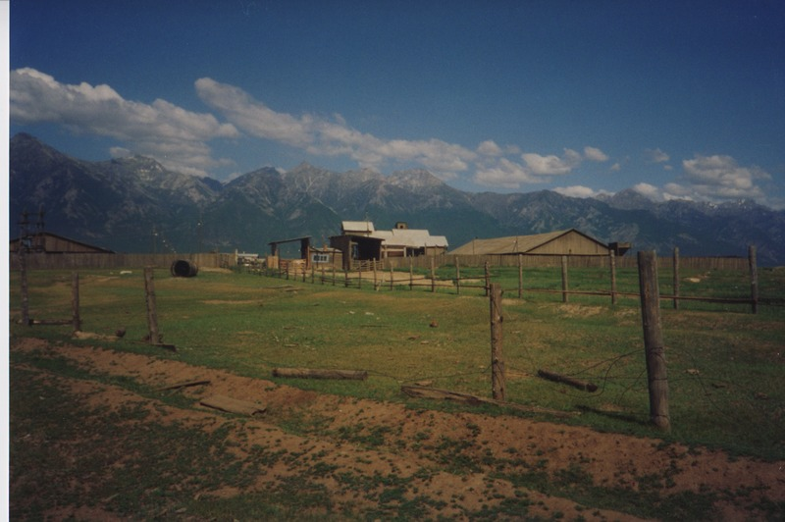

### identifier

c56faa63-9f76-47c8-9883-727eea02144c

### creator

Humphrey, Caroline

### type

Image

### coverage

Bayangol

Khilgana

Karl Marx Collective

Buryatia

USSR

### description

### publisher

### source

Scanned from a print held in the archives of the Mongolia and Inner Asia Studies Unit, University of Cambridge.

### rights

### subject

### date

1993

### language

### extent

3.2MiB

1799x1196 px

### contributor

### original filename

Humphrey-Buryatia-photos-2-16.png

### relation

### format

image/png