2326816. Badma Narmaev, A Legend About the Bogdo Uul Mountain

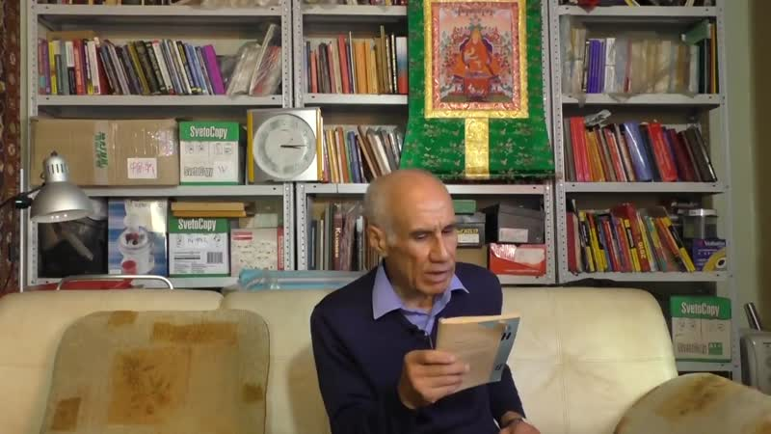

### identifier

c588908d-34e6-435a-b3f4-e256be4d59b7

### creator

Kalmyk Cultural Heritage Documentation Project

### type

Moving Image

### coverage

Kalmykia

Russia

### description

Bogdo Uul is situated near lake Baskunchak in Akhtubinsky rayon of Astrakhan’ oblast. There are several versions of the legend about the mountain. A version that Badma recounts is what he heard from the Kalmyk writer Sandzhi Kalyaev. Once upon a time a hero called Geser came to the Kalmyk steppes and stopped at the bottom of Bogdo Uul Mountain. It was forbidden for people to look at the mountain, for those who did so died. By conjuring up fog, Geser covered the mountain with it and safely climbed up to the top from where he could clearly see the palace of an enemy khan. With a huge arrow shot from his bow Geser slashed the palace in two. The destroyed palace turned into the snowy mountain of Elbrus that has two peaks.

### publisher

University of Cambridge

### source

<http://www.kalmykheritage.socanth.cam.ac.uk>

### rights

Copyright Kalmyk Cultural Heritage Documentation Project. Licensed under a Creative Commons BY-NC-ND Unported license.

### subject

Buddhism

Kalmyks

### date

2016-09-28 06:17:46

### language

### extent

46.3 MiB

124.160000

### format

video/mp4

### modified

2017-05-27 10:45:46

### original filename

2326825.mp4

### remote embed url

http://sms.cam.ac.uk/media/2326816/embed

### public

FALSE