“Гоё тараг” хятадынх биш гэдгийг баталлаа › Цахим сэтгүүлзүйн хурд - Bataar.mn

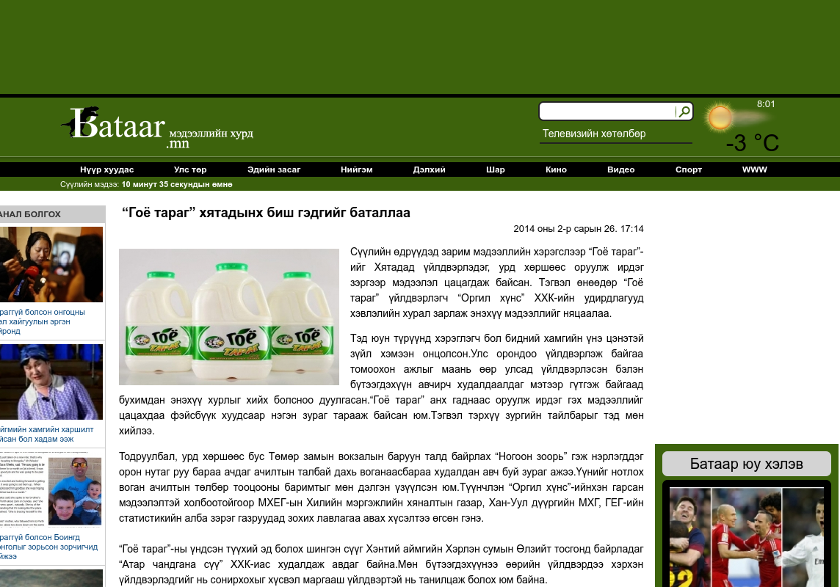

### identifier

c7f9378c-cfed-4f3e-98ed-5d647ad2dc89

### creator

### type

Text

### coverage

Mongolia

### description

### publisher

### source

http://www.bataar.mn/10020542

### rights

### subject

Mongolia

dairy

nationalism

social media

### date

24 Mar 2014 10:48:32

### language

Mongolian

### format

text/plain

### modified

2018-01-11 14:12:43

### original filename

baatar.mn.Khyatadynkh_bish.url

### extent

29.0 B