Caroline Humphrey - Buryatia photos - No. 4-05

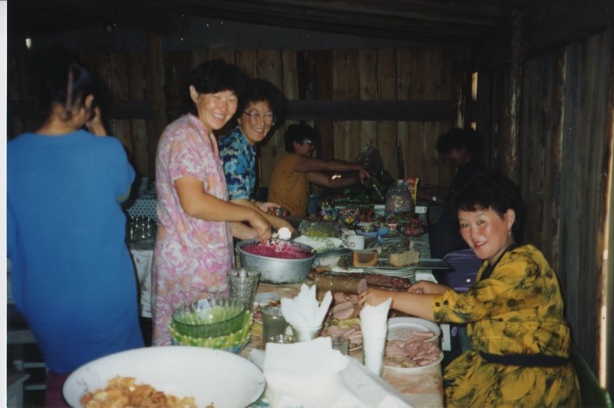

### identifier

c895cf32-34ca-477f-8648-e97316d41d41

### creator

Humphrey, Caroline

### type

Image

### coverage

Uro

Bayangol

Buryatia

USSR

### description

Wedding preparations -- making salads.

### publisher

### source

Scanned from a print held in the archives of the Mongolia and Inner Asia Studies Unit, University of Cambridge.

### rights

### subject

### date

1993

### language

### contributor

### original filename

Humphrey-Buryatia-photos-4-05.png

### relation

### extent

3.3MiB

1799x1196 px

### format

image/png