Хуурай сүүний тухай үнэнийг өчих нь | Food Industry

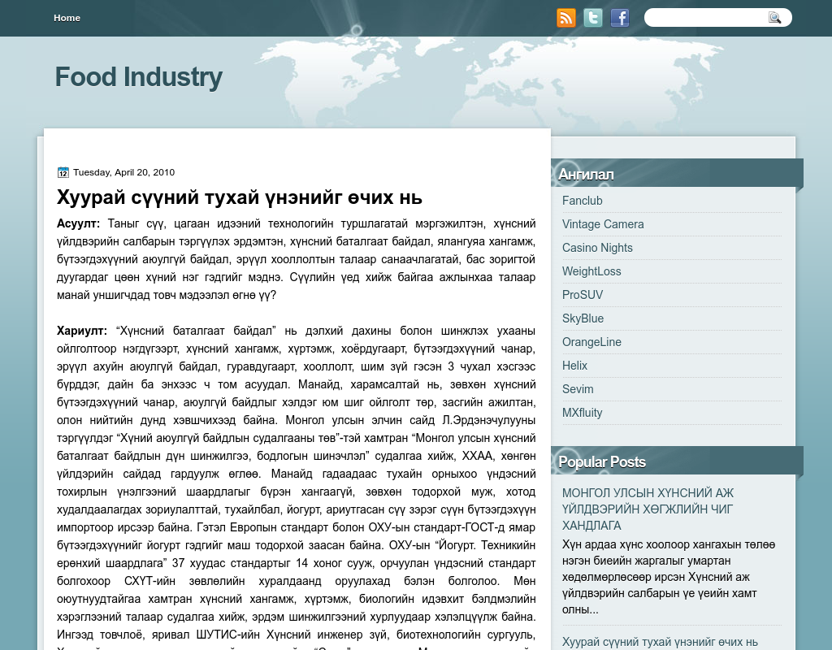

### identifier

c8a78d75-e14a-4d3b-9ec8-3da3b1e7a0e5

### creator

### type

Text

### coverage

Mongolia

### description

### publisher

### source

http://www.fim-must.com/2010/04/blog-post.html

### rights

### subject

Mongolia

dairy

nationalism

social media

### date

25 Mar 2014 19:00:48

### language

Mongolian

### format

text/plain

### modified

2018-01-11 14:12:43

### original filename

fim-must.com.Khuurai_suu.url

### extent

46.0 B