David Sneath - photographs from Xingmeng, Yunnan - No. 11

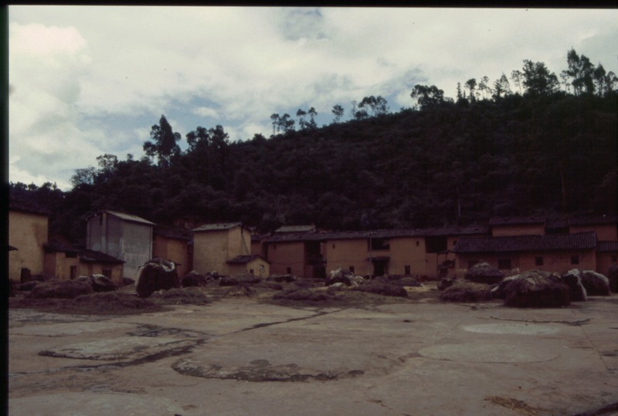

### identifier

c97fa18f-014a-4665-9fb5-55e9095070ff

### creator

Sneath, David

### type

Image

### coverage

PRC

Yunnan

### description

### publisher

### source

Digitized from a 35mm slide provided by the author.

### rights

### subject

### date

1997

### language

### format

image/tiff

### contributor

### original filename

David Sneath - photographs from Xingmeng, Yunnan - No. 11.tif

### relation

### extent

42.6MiB

4704x3168 px

### public