Caroline Humphrey - Buryatia photos - No. 14

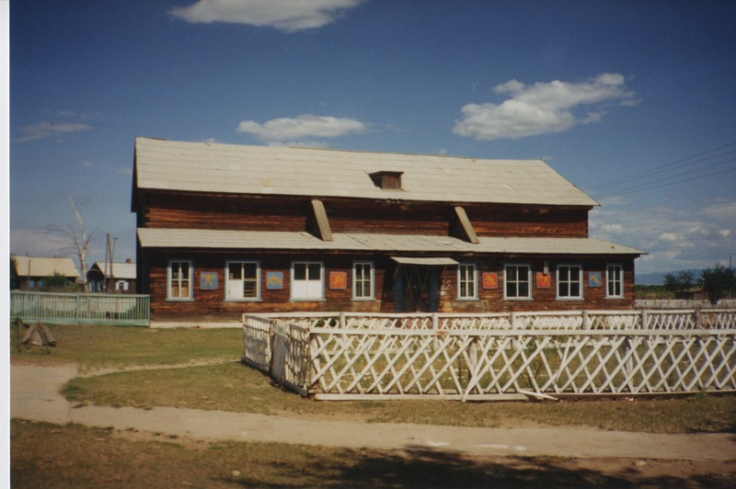

### identifier

ca4e650d-b147-4ccf-afb9-152eab9e347d

### creator

Humphrey, Caroline

### type

Image

### coverage

Ulung Collective

Buryatia

USSR

### description

School gymnasium.

### publisher

### source

Scanned from a print held in the archives of the Mongolia and Inner Asia Studies Unit, University of Cambridge.

### rights

### subject

### date

1993-07-25

### language

### contributor

### original filename

Humphrey-Buryatia-photos-14.png

### relation

### extent

3.3MiB

1799x1196 px

### format

image/png