Yeröö sheep morning husbandry activities

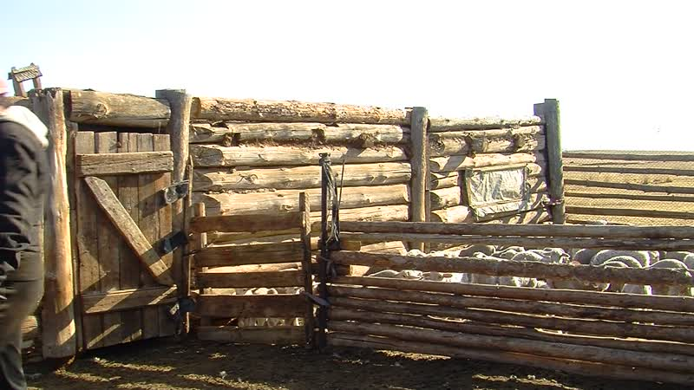

### identifier

d08d7520-2ee9-469f-af7c-526ba9966063

### creator

Thrift, Eric

### type

Moving Image

### coverage

Mongolia

Selenge aimag

Yeröö sum

### description

This series of audiovisual recordings documents a morning visit with veterinarian Mönkhbayar to the household in charge of the aimag "nucleus herd", thoroughbred livestock of the Yeröö breed which are owned by the State and kept for selective breeding purposes. The family take the sheep out of the shelter, bring the lambs to their mothers to suckle, then send off the adult sheep, setting out bran for the younger animals that are left behind. They then rake clean the livestock enclosure.

### publisher

### source

### rights

### subject

Pastoralism Videos

Yeroo Sheep

Morning Activities

### date

2012-04-08

### language

### remote embed url

https://archive.org/embed/d08d7520-2ee9-469f-af7c-526ba9966063

### format

inode/directory

### modified

2018-01-17 20:15:05

### original filename

PastoralismVideos--2012-04-08--YerooSheep--MorningActivities--Selenge-Yeroo.vclips

### table of contents

|  |  |  |
| --- | --- | --- |
| time | clip | description |
| 0:00:00 | 244 0266 01 |  |
| 0:13:53 | 244 0266 02 |  |
| 0:27:47 | 244 0266 03 |  |
| 0:37:20 | 244 0267 01 |  |
| 0:42:58 | 244 0268 01 |  |