Sample handwritten notes from ethnographic interview (English)

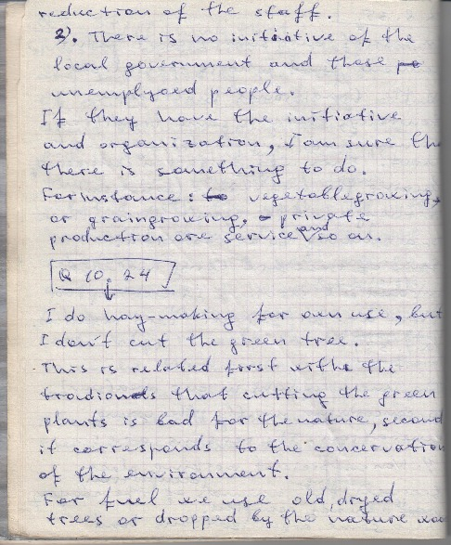

### identifier

d2e8360a-0983-4fd7-8bfe-ad3ce061fad4

### creator

Telengid, B

### type

Text

### coverage

Mongolia

### description

### publisher

### source

Scanned from an original document held in the archives of the Mongolia and Inner Asia Studies Unit, University of Cambridge.

### rights

### subject

ethnographic interviews

fieldnotes

### date

ca. 1992

### language

English

### original filename

Telengid-interview-fieldnotes-english-sample.pdf

### relation

### extent

1.4 MiB

### contributor

### format

application/pdf

### modified

2017-05-25 10:34:32