Caroline Humphrey Mongolia Super8 film no. 8

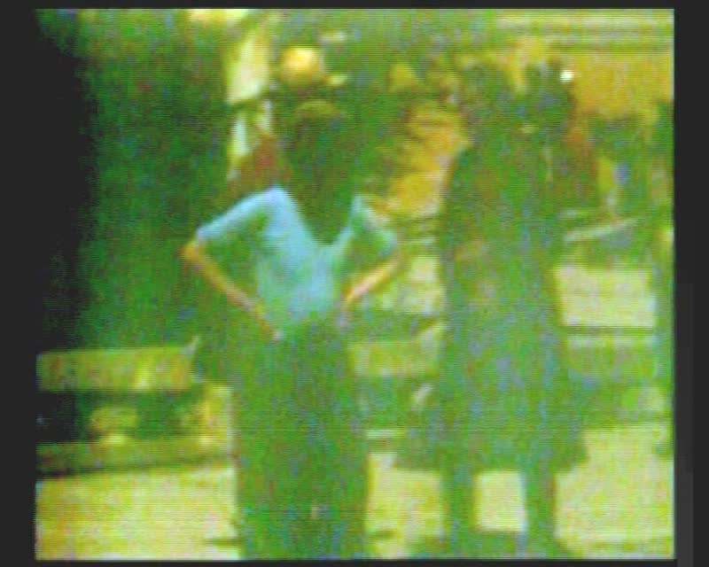

### identifier

d388bc43-b6d3-4a4d-a0d9-1e6ce24d21ff

### creator

Humphrey, Caroline

### type

Moving Image

### coverage

Mongolia

Ulaanbaatar

### description

Visitors to Gandan Monastery, Ulaanbaatar (exterior).

### publisher

MIASU

### source

Digitized from a VCR transfer tape held at the Mongolia and Inner Asia Studies Unit, University of Cambridge

### rights

Copyright Caroline Humphrey

### subject

monasteries

pilgrims

### date

ca. 1970s

### language

None

### original filename

humphrey-super8-mongolia-08.mp4

### extent

694.2 MiB

128.192000

### format

video/mp4

### modified

2017-06-16 10:12:01

### alternate url

https://archive.org/embed/d388bc43-b6d3-4a4d-a0d9-1e6ce24d21ff