Тэсо Корпораци Зөв аарцны ундаа Ясны сийрэгжилтийн эсрэг

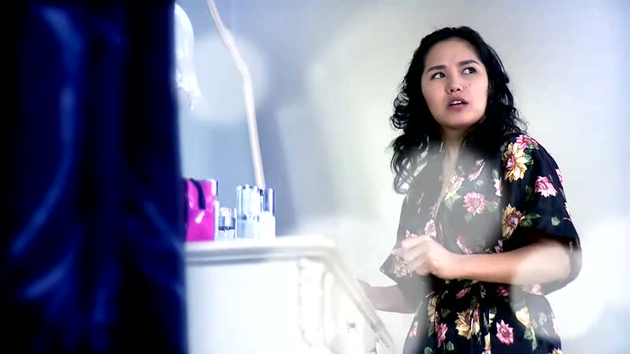

### identifier

d39749f2-dd19-4ba1-b281-80fb29e091b8

### creator

TESO LLC

### type

Moving Image

### coverage

### description

TV commercial for aarts (fermented curd) beverage - "Good fermented curd beverage combats osteoporosis"

### publisher

### source

<http://youtu.be/zEfBrQUhlGg>

### rights

### subject

Mongolia

Dairy Production

Milk Marketing

Television Commercials

### date

2011-03-24 13:24:52

### language

### format

video/mp4

### modified

2014-02-04 01:55:33

### extent

11.2 MiB

30.160000