Photograph from Govisumber, No. 08

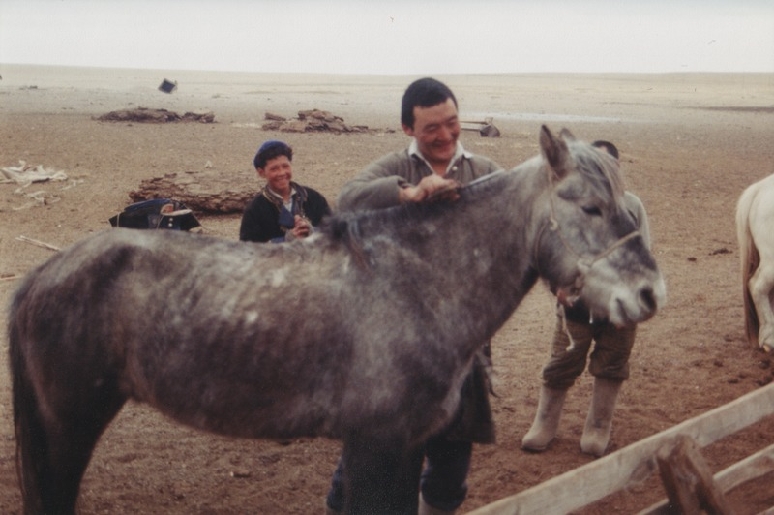

### identifier

d4651165-ad6c-40cf-8a03-c2f248aefe55

### creator

Sneath, David

### type

Image

### coverage

Govisumber aimag

Mongolia

### description

### publisher

### source

scanned from a photographic print held in the archives of the Mongolia and Inner Asia Studies Unit, University of Cambridge

### rights

### subject

clipping horse mane

horses

### date

1995

### language

### format

image/png

### contributor

### original filename

sneath-govisumber_08.png

### relation

### extent

1776x1182 px

3.1MiB