A Mongolian search for anthropology (interview with Uradyn Bulag)

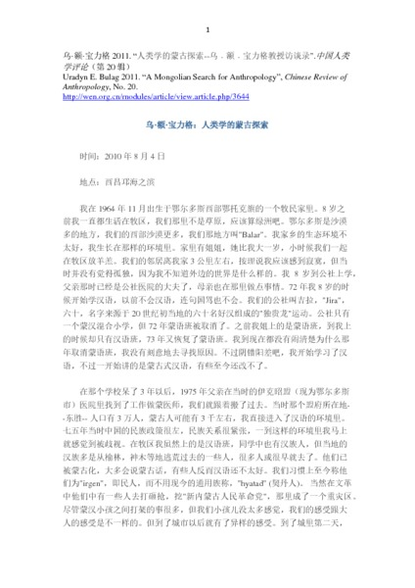

### identifier

d4de90f3-3fb6-4211-bc62-7159e6d04b7d

### creator

Bulag, Uradyn E

### type

Text

### coverage

Inner Mongolia

PRC

### description

Interview with Uradyn Bulag about his childhood and career in anthropology. “In the early 1980s, China had such a big atmosphere: the cultural and political development of Beijing and Shanghai, and the controversy inevitably affected the national relations of the frontier. Inner Mongolia is a border ethnic minority areas, our school is Mongolia, Hansheng half of the students there are also ethnic relations. In the university, the Han students think they are superior, but the Mongolian students admit defeat. Mongolians are a bit different from other Chinese ethnic minorities, and we rarely have a sense of inferiority because we have a sense of history....”

### publisher

Chinese Review of Anthropology

### source

Anthropology, No. 20

Uradyn E. Bulag 2011. “A Mongolian Search for Anthropology”, Chinese Review of

http://wen.org.cn/modules/article/view.article.php/3644

### rights

### subject

autobiography

ethnicity

nationalism

### date

2010-08-04

### language

Chinese

### extent

1.3MiB

### format

application/pdf

### contributor

### relation

8bdb481b-5851-43c5-8175-c385d675e3c6

### original_filename

2010-interview.pdf

### public