4019

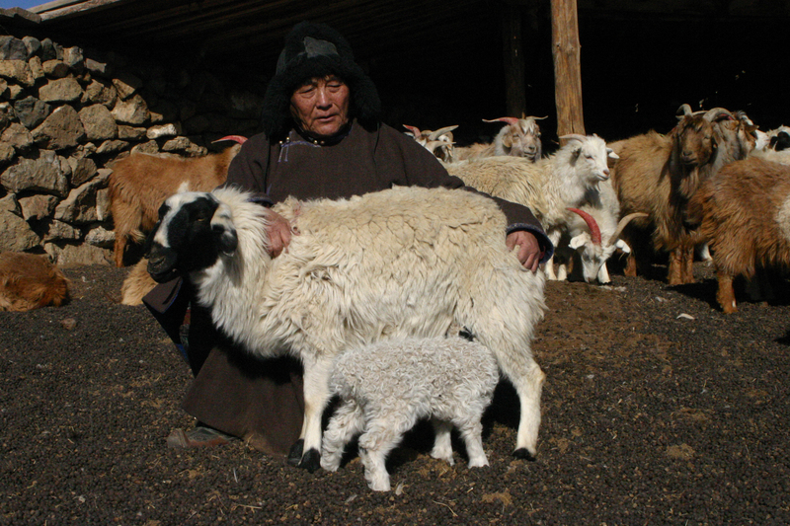

### identifier

da2d9f1f-d400-4878-a3f9-e2822d8e14b9

### creator

Boldbaatar, Yu.

### type

Image

### coverage

Mongolia

### description

Coaxing a baby by female sheep

### publisher

### source

https://ich.unesco.org/img/photo/src/4019.jpg

### rights

### subject

### date

2010

### language

### original filename

04019.jpg

### extent

4.1 MiB

3072x2048 px

### format

image/jpeg

### modified

2012-12-05 02:28:26