Photograph from Inner Mongolia, No. 17

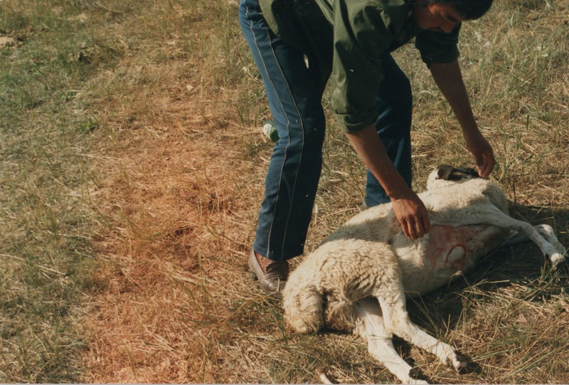

### identifier

db2f376b-3ae4-4f19-a48b-e35a0a842f3e

### creator

Sneath, David

### type

Image

### coverage

Inner Mongolia

PRC

### description

Slaughtering a sheep.

### publisher

### source

Scanned from a photographic print held in the archives of the Mongolia and Inner Asia Studies Unit, University of Cambridge.

### rights

### subject

sheep slaughter

### date

ca. 1988

### language

### original filename

sneath-inner-mongolia-1980s.png_17.png

### relation

### extent

3.6 MiB

1747x1182 px

### contributor

### format

image/png

### modified

2017-05-25 11:09:02