Темкагийн төрсөн өдөр ба Монгол төрийн “Хятаджих” бодлого | Caak.mn

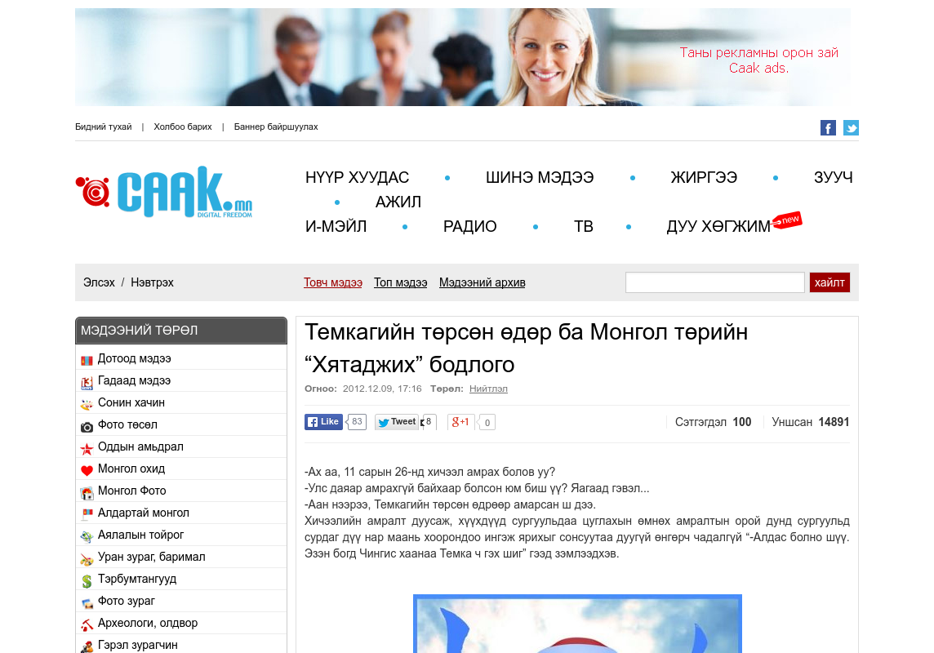

### identifier

dbc62b6c-ee4e-4f51-8a4b-f98bc1373df2

### creator

### type

Text

### coverage

Mongolia

### description

### publisher

### source

http://www.caak.mn/view/8251060/

### rights

### subject

Mongolia

dairy

nationalism

social media

### date

24 Mar 2014 17:55:10

### language

Mongolian

### format

text/plain

### modified

2018-01-11 14:12:43

### original filename

caak.mn.Temkaagiin_torson_odor.url

### extent

32.0 B