Blessing a camel

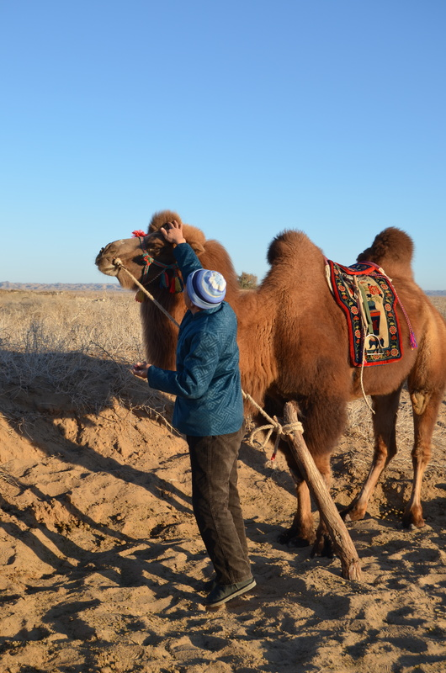

### identifier

dc2c9322-5510-4ae2-b596-a905de968120

### creator

White, Thomas

### type

Image

### coverage

Alashan

Inner Mongolia

PRC

### description

Blessing a camel (myalaakh) prior to a race.

### publisher

### source

Image submitted by the author.

### rights

Copyright Thomas White. All rights reserved. Please contact the author for information on re-use.

### subject

camels

### date

2013-11-07 01:32:18

### language

### format

image/jpeg

### contributor

### original filename

DSC_0017.JPG

### relation

### extent

4.0MiB

4928x3264 px