Map of the Ethno-Linguistic groups of Central Asia

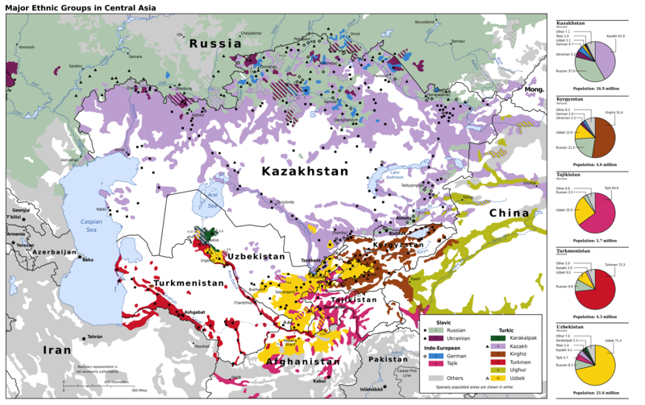

### identifier

ddd5cebc-5616-4085-b673-dabb452b4153

### creator

CIA

Wikimedia Commons User:Pmx

### type

Image

### coverage

Central Asia

### description

Ethno-linguistic map of Central Asia

### publisher

Wikimedia Commons

### source

<https://commons.wikimedia.org/wiki/File:Central_Asia_Ethnic_en.svg>

### rights

Based on a public domain work.

This file is licensed under the Creative Commons Attribution-Share Alike 3.0 Unported license.

### subject

languages

maps

### date

12/2009; source map was from 1992

### language

English

### format

image/svg+xml

### modified

2013-02-07 04:59:11

### extent

1.2 MiB