Living with Herds: Human-animal coexistence in Mongolia

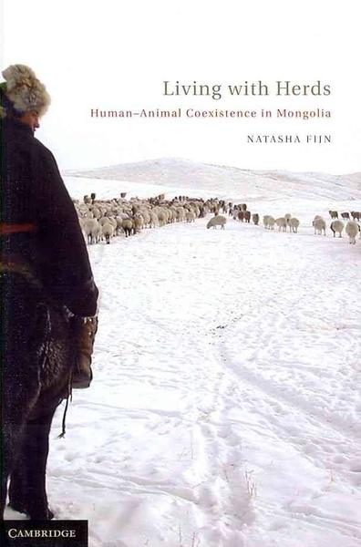

### identifier

df6b0204-7aa1-48c0-8bc7-e9abe079d6ec

### creator

Fijn, Natasha

### type

Image

### coverage

Mongolia

### description

From the publisher: Domestic animals have lived with humans for thousands of years and remain essential to the everyday lives of people throughout the world. In this book, Natasha Fijn examines the process of animal domestication in a study that blends biological and social anthropology, ethology and ethnography. She examines the social behavior of humans and animals in a contemporary Mongolian herding society. After living with Mongolian herding families, Dr Fijn has observed through firsthand experience both sides of the human-animal relationship. Examining their reciprocal social behavior and communication with one another, she demonstrates how herd animals influence Mongolian herders' lives and how the animals themselves are active partners in the domestication process.

### publisher

Cambridge University Press

### source

### rights

Copyright

### subject

### date

2011

### language

Mongolian

### format

image/jpeg

### contributor

### original filename

living-with-herds-book-cover.jpg

### remote embed url

### relation

c44544f5-f99f-4a9c-a83e-a0e90bfbd555

### extent

37.9KiB

607x920 px