Operations at Sain Tus Farm and Dairy, Sainshand

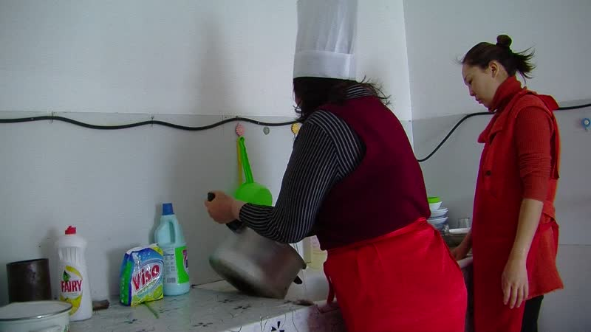

### identifier

e0436318-3792-4b8e-8a9a-2dbd90743c51

### creator

Thrift, Eric

### type

Moving Image

### coverage

Mongolia

Dornogovi aimag

Sainshand sum

### description

This series of audiovisual recordings represents the daily activities at Sain Tus Farm, just to the north of Sainshand, and at its dairy in town. The business is operated by Önörbayar, a former schoolteacher who engaged in private business for more than a decade prior to opening the dairy operation, and her family; the cattle are managed by Önörbayar's husband and a hired hand. This operation has benefited from support provided by the US Department of Agriculture through Mercy Corps Mongolia (subsidized loans for dairy equipment, and free training in dairy processing), and from the Government of Mongolia (subsidized connection of the farm to the power grid). In the first part of the series, the farm owners and staff milk the cattle and load milk onto their truck for transport into town. In the second part, Önörbayar discusses her work and its challenges as she separates cream and pasteurizes milk.

### publisher

### source

### rights

### subject

Pastoralism Videos

Sain Tus Dairy

Milking Cattle

Pasteurizing Milk

Making Yoghurt

### date

2012-03-10

### language

### format

inode/directory

### modified

2018-01-17 20:15:05

### original filename

PastoralismVideos--2012-03-10--SainTusDairy--MilkingCattle--PasteurizingMilk--MakingYoghurt--Dornogovi-Sainshand.vclips

### table of contents

|  |  |  |
| --- | --- | --- |
| time | clip | description |
| 0:00:00 | 244 0172 01 |  |
| 0:13:53 | 244 0172 02 |  |
| 0:27:48 | 244 0172 03 |  |
| 0:41:42 | 244 0172 04 |  |
| 0:55:36 | 244 0172 05 |  |
| 1:04:26 | 244 0173 01 |  |
| 1:18:20 | 244 0173 02 |  |
| 1:32:14 | 244 0173 03 |  |
| 1:46:08 | 244 0173 04 |  |
| 1:51:29 | 244 0174 01 |  |
| 1:58:41 | 244 0174 02 |  |
| 2:12:35 | 244 0174 03 |  |
| 2:15:37 | 244 0175 01 |  |
| 2:19:33 | 244 0176 01 |  |
| 2:21:45 | 244 0177 01 |  |