Монголын угсаатны зүйн үндэс [Foundations of Mongolian ethnography]

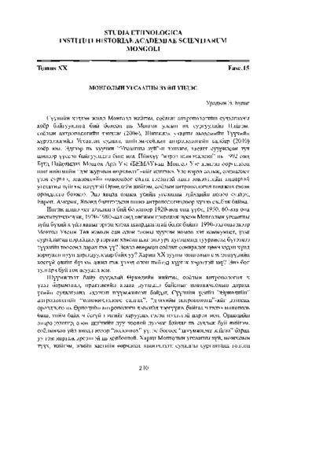

### identifier

e13b89b2-c2ba-4500-afc1-55d8c6f82e8c

### creator

Bulag, Uradyn E

### type

Text

### coverage

Mongolia

### description

Essay on the origins of Mongolian ethnography

### publisher

Institute of History, Mongolian Academy of Sciences

### source

Studia Ethnologica 20(15): 210--227

### rights

### subject

Mongolian ethnography

indigenous anthropology

### date

2011

### language

Mongolian

### extent

253.0KiB

### format

application/pdf

### contributor

### relation

### original_filename

Mongolyn_Ugsaatny-zuin-undes.pdf

### public