Vitafit factory tour image - 85iihr85jhvhr22ae0cr3b2um l

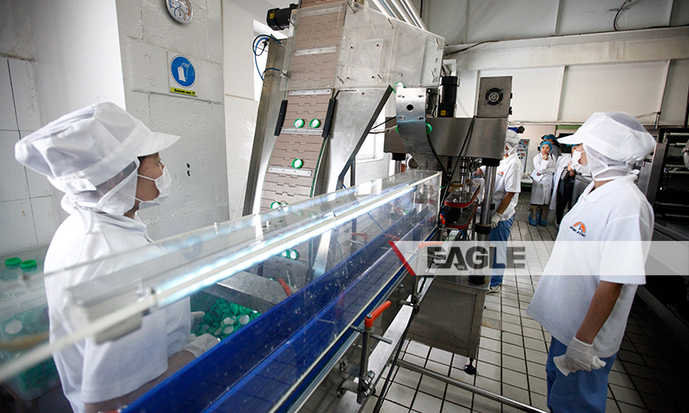

### identifier

e2b57d14-9ba3-44de-bdb4-c38cd70b8040

### creator

### type

Image

### coverage

Mongolia

### description

Goyo yogurt factory tour image published by Eagle.mn.

### publisher

### source

### rights

### subject

Mongolia

dairy

nationalism

social media

### date

2014

### language

Vitafit factory tour image - Vitafit factory tour image - 85iihr85jhvhr22ae0cr3b2um l

### format

image/jpeg

### original filename

85iihr85jhvhr22ae0cr3b2um_l.jpg

### extent

388.8 KiB

800x480 px

### modified

2014-03-24 18:29:16