Frontier encounters: Knowledge and practice at the Russian, Chinese and Mongolian border

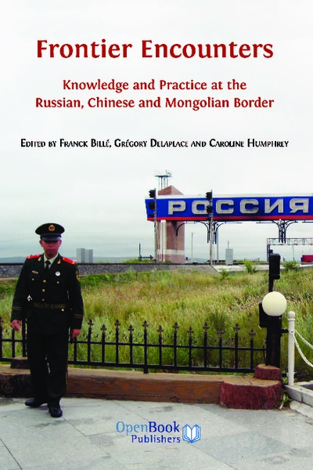

### identifier

e7b013d9-c33f-41b8-806c-af31b7ab81d1

### creator

Billé, Franck

Delaplace, Grégory

Humphrey, Caroline

### type

Text

### coverage

### description

(From the publisher) China and Russia are rising economic and political powers that share thousands of miles of border. Yet, despite their proximity, their practical, local interactions with each other — and with their third neighbour Mongolia — are rarely discussed. The three countries share a boundary, but their traditions, languages and worldviews are remarkably different.

*Frontier Encounters* presents a wide range of views on how the borders between these unique countries are enacted, produced, and crossed. It sheds light on global uncertainties: China’s search for energy resources and the employment of its huge population, Russia’s fear of Chinese migration, and the precarious economic independence of Mongolia as its neighbours negotiate to extract its plentiful resources.

Bringing together anthropologists, sociologists and economists, this timely collection of essays offers new perspectives on an area that is currently of enormous economic, strategic and geo-political relevance.

This collective volume is the outcome of a network project funded by the ESRC (RES-075-25_0022) entitled "Where Empires Meet: The Border Economies of Russia, China and Mongolia". The project, based at the Mongolia and Inner Asia Studies Unit (University of Cambridge), ran from 28 January 2010 to 27 January 2011. That project formed the foundation for a new and ongoing research project "The life of borders: where China and Russia meet" which commenced in October 2012.

### publisher

Open Book Publishers

### source

<http://www.openbookpublishers.com/reader/139>

### rights

Creative Commons Attribution 3.0 Unported Licence

### subject

hybridity

frontiers

### date

2017-05-25 10:54:48

### language

English

### original filename

Frontier-Encounters-v1.1.pdf

### extent

13.6 MiB

### format

application/pdf

### modified

2017-05-25 08:39:30