Caroline Humphrey Mongolia Super8 film no. 14

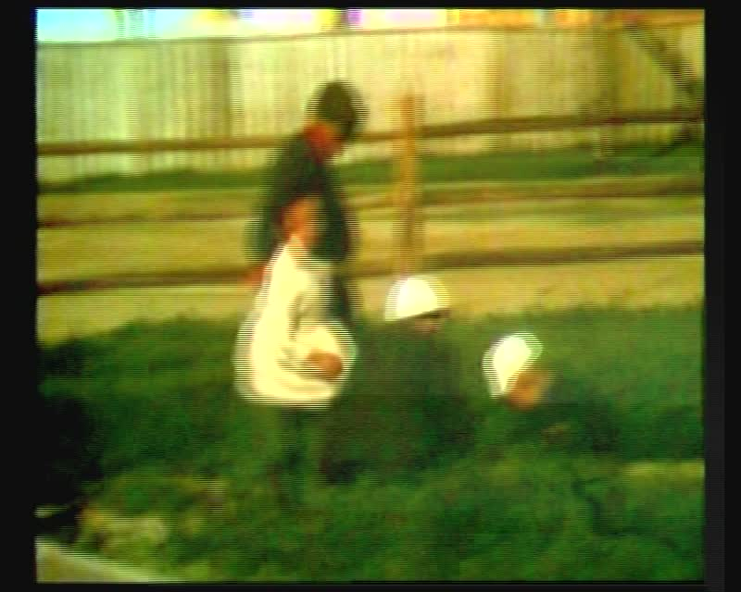

### identifier

e85efe3f-2384-48f6-9915-3e22c222e309

### creator

Humphrey, Caroline

### type

Moving Image

### coverage

Mongolia

Ovorkhangai aimag

### description

Khujirt (Ovorkhangai aimag). People walking; goat; bird; horse; residential area.

### publisher

MIASU

### source

Digitized from a VCR transfer tape held at the Mongolia and Inner Asia Studies Unit, University of Cambridge

### rights

Copyright Caroline Humphrey

### subject

aimag centres

### date

ca. 1970s

### language

None

### original filename

humphrey-super8-mongolia-14.mp4

### extent

960.0 MiB

215.403000

### format

video/mp4

### modified

2017-06-16 10:45:12

### alternate url

https://archive.org/embed/e85efe3f-2384-48f6-9915-3e22c222e309