9411

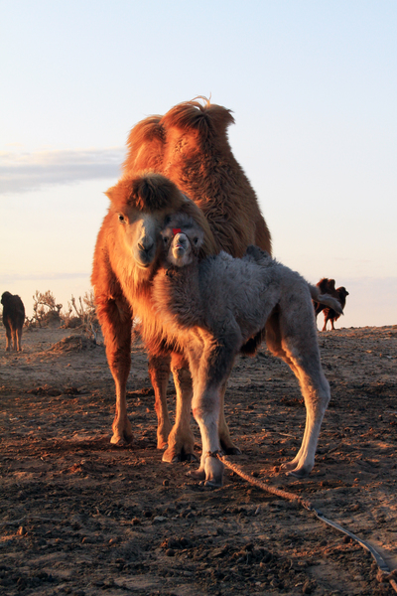

### identifier

e87dd0b6-8d5b-488b-8dbe-ca4ba6bd24eb

### creator

Boldbaatar, Yu.

### type

Image

### coverage

Mongolia

Ömnögovi aimag

Mandal-Ovoo sum

### description

The mare-camel and accepted new calf

### publisher

### source

https://ich.unesco.org/img/photo/src/09411.jpg

### rights

### subject

### date

2013

### language

### original filename

09411.jpg

### extent

9.7 MiB

3456x5184 px

### format

image/jpeg

### modified

2016-02-24 14:47:08