Mongolia and Inner Asia Studies

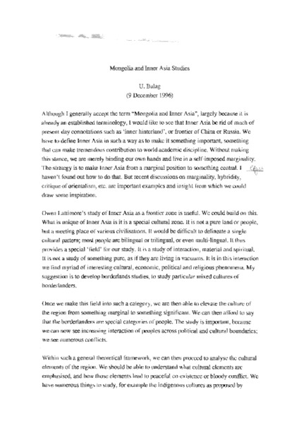

### identifier

ec2a2c79-0225-44f4-9e0d-77e1a0b7a351

### creator

Bulag, Uradyn E

### type

Text

### coverage

Inner Asia

### description

Short discussion note addressing the terminological category of “Mongolia and Inner Asia”. Bulag argues that whereas the concept of Inner Asia bears connotations of marginality, frontier, or hinterland status, Inner Asia must be brought out of the periphery and into the centre.

### publisher

### source

Scanned from a printout held in the archives of the Mongolia and Inner Asia Studies Unit, University of Cambridge

### rights

### subject

Inner Asia

terminology

### date

1996-12-09

### language

English

### extent

902.0KiB

### format

application/pdf

### contributor

### relation

### original_filename

Bulag-note-Mongolia-and-Inner-Asia-studies.pdf

### public