"Mongol Temee 2012" [Mongolian Camel 2012] festival (day one).

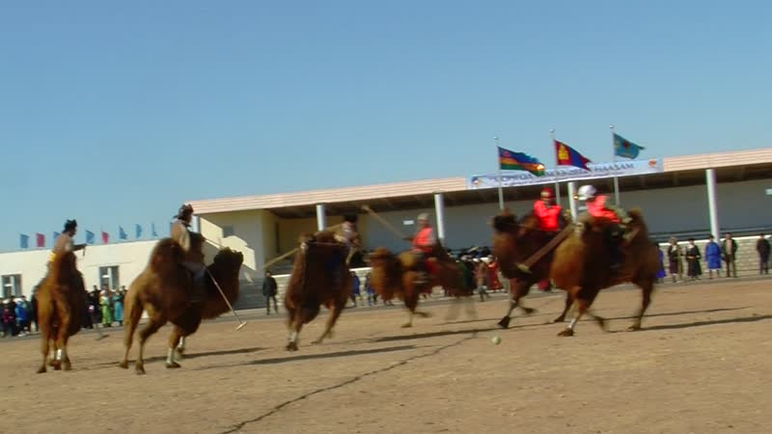

### identifier

ec32b49d-97cf-4ed6-8555-8986e2e8a015

### creator

Thrift, Eric

### type

Moving Image

### coverage

Mongolia

Dornogovi aimag

Sainshand sum

### description

This series includes videos of events on the first day of the "Mongol Temee 2012" camel festival in Dornogovi. The first recordings depict the opening ceremony, in which participants from each sum parade into the aimag stadium and are greeted by blessings from local officials, and sum veterinary and livestock breeding units from each sum are presented a new van. After the opening ceremony, the camel polo competition begins. At midday the festival participants parade through the streets of Sainshand, meeting with the staff of various organizations--including the aimag museum--who receive them on carpets laid out in the street, ceremonially offering tea and meat. The camel polo competition resumes in the afternoon.

### publisher

### source

### rights

### subject

Pastoralism Videos

Camel Festival

Camel Polo

### date

2012-02-11

### language

### format

inode/directory

### modified

2018-01-17 20:15:05

### original filename

PastoralismVideos--2012-02-11--CamelFestival--CamelPolo--Dornogovi-Sainshand.vclips

### table of contents

|  |  |  |
| --- | --- | --- |
| time | clip | description |
| 0:00:00 | 244 0019 01 |  |
| 0:01:17 | 244 0020 01 |  |
| 0:01:36 | 244 0021 01 |  |
| 0:02:28 | 244 0022 01 |  |
| 0:02:55 | 244 0023 01 |  |
| 0:03:28 | 244 0024 01 |  |
| 0:17:22 | 244 0024 02 |  |
| 0:31:16 | 244 0024 03 |  |
| 0:45:10 | 244 0024 04 |  |
| 0:56:45 | 244 0025 01 |  |
| 0:58:40 | 244 0026 01 |  |
| 0:59:53 | 244 0027 01 |  |
| 1:00:41 | 244 0028 01 |  |
| 1:02:39 | 244 0029 01 |  |
| 1:07:40 | 244 0030 01 |  |
| 1:21:34 | 244 0030 02 |  |
| 1:25:35 | 244 0032 01 |  |
| 1:29:18 | 244 0033 01 |  |
| 1:29:21 | 244 0034 01 |  |
| 1:42:22 | 244 0035 01 |  |
| 1:47:19 | 244 0036 01 |  |
| 1:49:35 | 244 0037 01 |  |
| 1:59:59 | 244 0038 01 |  |
| 2:02:40 | 244 0039 01 |  |
| 2:03:21 | 244 0040 01 |  |
| 2:08:19 | 244 0041 01 |  |
| 2:08:55 | 244 0042 01 |  |
| 2:08:56 | 244 0043 01 |  |
| 2:12:06 | 244 0044 01 |  |
| 2:19:23 | 244 0045 01 |  |
| 2:19:26 | 244 0046 01 |  |
| 2:21:45 | 244 0047 01 |  |
| 2:22:03 | 244 0048 01 |  |
| 2:22:22 | 244 0049 01 |  |
| 2:23:00 | 244 0050 01 |  |
| 2:23:08 | 244 0051 01 |  |
| 2:24:19 | 244 0052 01 |  |
| 2:25:02 | 244 0053 01 |  |
| 2:38:57 | 244 0053 02 |  |
| 2:39:13 | 244 0054 01 |  |
| 2:53:07 | 244 0054 02 |  |
| 2:54:58 | 244 0055 01 |  |