Oral history interview No. 081223A with Ichinhoroloo (b. 1956): translation

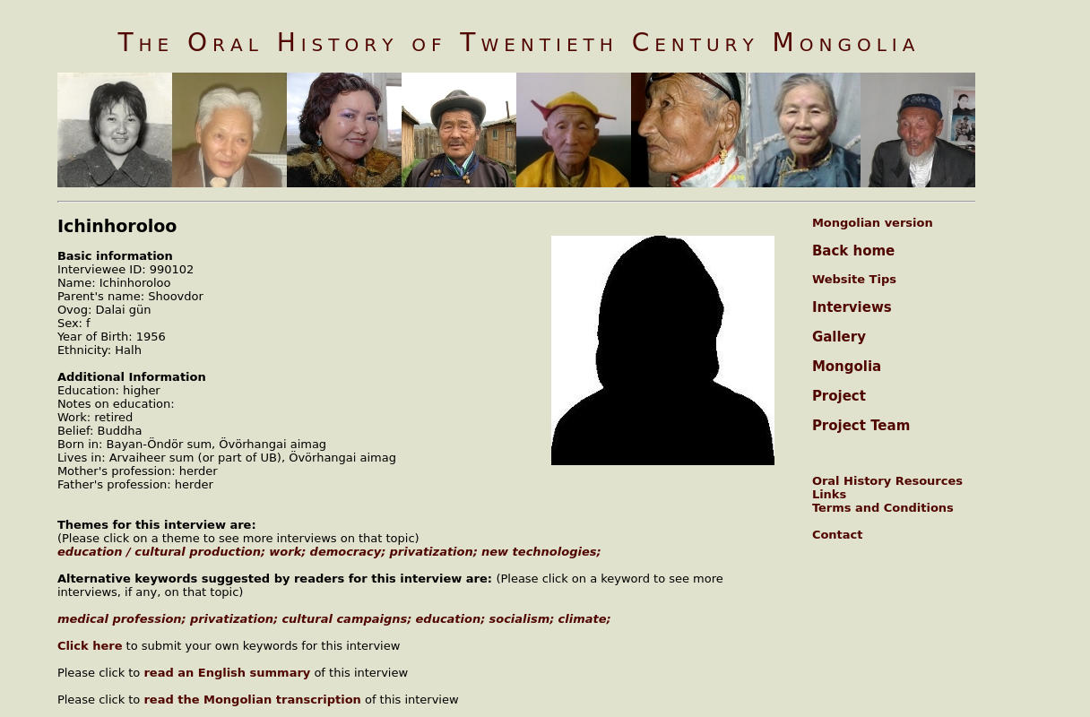

### identifier

ec39f19d-2b6d-4245-8560-5858394e0321

### creator

Ichinhoroloo

### type

Text

### coverage

Mongolia

Övörhangai aimag

### description

Ichinhorloo was born in Bayan-Ӧndӧr sum of Ӧvӧrhangai aimag in 1956. Her father, Shoovdor, was a herder and had six children. After finishing the eighth grade in Bayan- Ӧndӧr in 1972, Ichinhorloo married a local man and gave birth to five children. In 1985, she entered medical college, after the completion of which she worked as a doctor at an epidemiological station for eighteen years. Ichinhorloo heard of the ‘cultural campaigns’, but says that she cannot provide any detailed information. Her first job was to wait tables in a dining hall in Ӧvӧrhangai aimag centre. As a girl with only eight years of education she struggled to find a job, and managed to get one only with the help of her relatives. In the interview she tells what she bought with her salary, pointing out that in socialist Mongolia goods were scarce, especially in the country-side. After the college, however, she did not have to look for a job, for it was the state’s responsibility to find her one. Like any other student in socialist Mongolia, she did not have to pay for the college education, on the contrary was paid to study. She had a good stipend. Before the democratic changes, the main source of information, according to Ichinhorloo, was lectures and meetings organised by the trade committees. Ichinhorloo thinks that democracy did not affect her life in any way. She did not participate in the privatisation. In contrast with today’s society, in socialist Mongolia people were more serious and had more grounded attitude towards life. In her view, today people became unreliable, light-minded, and divorce easily. In comparison with her childhood, the climate has changed for the worse.

### publisher

Oral History of Twentieth Century Mongolia

### source

<http://amantuuh.socanth.cam.ac.uk/search/view_trans.php?Interview=081223A>

### rights

Copyright MIASU. Reproduced with permission. Brief excerpts from interviews and other material may be used in academic or popular work for non-commercial purposes provided proper attribution and credit is given to the Oral History of Twentieth Century Mongolia and the Mongolia and Inner Asia Studies Unit (MIASU). You must not: (a) republish this material (including republication on another website) without the express written permission of MIASU; (b) sell, rent or sub-license material from the website; (c) show any material from the website in public without attribution to The Oral History of Twentieth Century Mongolia; (d) reproduce, duplicate, copy or otherwise exploit material on the website for a commercial purpose without express written permission; (e) use the material in any way that is damaging to the project or any of the persons named in the interviews. See <http://amantuuh.socanth.cam.ac.uk/terms.php> for details.

### subject

biomedicine

democracy

education

new technologies

oral history

privatization

work

### date

2009

### language

English

### format

text/plain

### contributor

Ganbold

### original filename

081223A-Ichinhoroloo-translation.url

### relation

ee78bf11-8c2d-4fbf-8162-34491f24be1e

### extent

74.0 B